**Software Requirements Specification for Online Book Sales with Mobile SMS**

**1 Introduction:**

* 1. **Purpose:**

Knowledge plays a very important role in day-to-day life. Book is the major source of Knowledge. People gather information from the books. Books are useful for us in several ways. The purpose of this project is to support the online purchasing of such great books. This website is named as Online Book Sales with Mobile SMS. This website holds the reviews of the customers about the books and their rating on them. It will also help the users to know the latest books of their interest being introduced into the market like fiction, science, technology etc.

* 1. **Scope:**

In Scope:

* The main scope of this project is to reduce the man power involved in sales and to reduce the efforts of searching books in each centre.
* The administration can have a direct communication with their customers.
* Customer can search their books and order books at any time.
* The entire stock is maintained at a single location.
* Upon arrival of new books, the customers are intimated via SMS.

Out of Scope:

* Mail generation.
* Tax computation for transport.
  1. **Definition, acronyms and abbreviations**

Definitions:

Users: Corporate users, Retail users, Non-members, Administrators and Stock manager.

Non-member: Any person who has not yet registered with the online book store system is treated as a non-member. Non-members can register with the system in order to become a member or can search for the books by category and author. They can also give feedback about site.

Corporate users: The members registered themselves in the site, who buy books in large quantities are denoted as corporate users. This category of users include library and book sellers (shopkeepers). The discount percentage will be more for the corporate users comparing to that of the retail users. The corporate users can search books, purchase books, rate and comment on the books.

Retail users: Members, who buy books in retail, are classified as retail users. These members can search and purchase books at a discount price applicable to them based on the points assigned to them depending upon the number of books that they have purchased so far. They can also suggest books to the other members or non-members.

Administrator: The administrator is the person who manages the overall system. It is (s)he who has the right to send SMS/Email to the customers. The registration link and the verification code are generated by the admin. The admin can view all the details of the customer in the database including their purchase history. He/she can also assign points to the users based on their transaction with the website.

Stock manager: The stock manager maintains the overall stock of the books available in the website. He can add books to the stock and can also remove them.

Abbreviation and Acronyms:

HTML: Hyper text Markup Language.

XML : Extensible Markup Language.

J2EE : Java 2 Enterprise Edition.

HTTPS: Source Hypertext Transfer Protocol.

HTTP: Hypertext Transfer Protocol.

* 1. **References:**
* Software Engineering concepts and practices

Ugrasen Suman

* Software Engineering concepts and practices

Roger S.Pressman.TMH 7th edition

* 1. **Document Overview:**

The remaining SRS will include three sections

* Overall description will describe major components of the system, inter connection and external interfaces.
* Specific requirements will describe the functions of actors, their role in the system and constraints.
* Supporting information will contain proposed user interface and the scope of extension of the project.

1. **General Description**
   1. **Product Perspective:**

The product perspective of this project are

* To develop a book management system.
* To design a book sales management system.
* To design a customer Mobile-Book sales management system interface which interacts with database system.

Online Book Sales with mobile mobile SMS is a standalone system that supports the online purchasing of such great books. It has support on both UNIX and Windows operating system.

* 1. **Product Functions:**

|  |  |  |  |
| --- | --- | --- | --- |
| **S.No.** | **Activity** | **Actors** | **Description** |
| 1 | Register | Non-member | Non-member must fill up the registration form in order to become members of the site. Once this is done, the administrator will confirm their registration after verifying their mobile number. |
| 2 | Login | Corporate user,  Retail user,  Administrator | Upon giving the username and password in the corresponding fields, the users are allowed to login if their password matches with their corresponding username. |
| 3 | Logout | Corporate user,  Retail user,  Administrator | Once the user clicks the logout button, the user will logged out and then their login status will be updated. |
| 4 | Search | Corporate user,  Retail user,  Administrator,  Non-member | After the selection of the category, author , a list of matching books will be displayed. |
| 5 | Subscribe | Corporate user,  Retail user | Once the customer is subscribed for particular categories of books, he/she will be intimated via SMS upon arrival of new book of that category. |
| 6 | Purchase | Corporate user,  Retail user | The customers can purchase books. The corporate users will be making a bulk purchase, whereas the retailer used to make retail purchase. |
| 7 | Cancel order | Corporate user,  Retail user | Placed order will be cancelled, if the status is not sent, after getting the reason for cancellation. |
| 8 | Make Payment | Corporate user,  Retail user | By choosing any one of the five payment types, the member can make payment for purchasing the books. |
| 9 | Feedback | Corporate user,  Retail user,  Non-members | Members and non-members can share their views about the website and they can also give any suggestion for the improvement of the website. |
| 10 | Order Status | Corporate user,  Retail user | Members can view the status of the given order by entering the given order ID. |
| 11 | Rate book | Corporate user,  Retail user | Members can add some values to book by rating it. |
| 12 | Modify Stock | Stock Manager,  Administrator | Books count will be managed by the stock manager. |
| 13 | View Stock | Stock Manager,  Administrator | Books available in the stock can be viewed by the stock manager and administrator. |
| 14 | Add Stock | Stock Manager,  Administrator | New books will be added to stock by the stock manager. |
| 15 | SMS | Administrator | Administrator can send verification code through SMS to a non-member during the registration process and also to the members who have subscribed for atleast one category. |

* 1. **User Characteristics:**
* The user must login to the system and registered to their accounts. The request can be made by the users.
* Reservation can also made for future usage.
* After they reserve the books they have to get an alert message through mobile SMS.
* Through mobile SMS, the users may know the latest book information that is being introduced into the market.
  1. **General Constraints:**
* Interface is in English.
* Only registered users will be authorized to purchase books.
* This system is working on a single server .
* Non-members can also search for the books.
  1. **Assumptions and dependencies**

In our project, we have made the following assumptions which facilitate the project development.

* Each member has mobile number.
* The date of birth given by a non-member during registration is correct.
* Shipping address provided by member while purchasing books is valid.

**3 Specific requirements**

**3.1 Functional requirements**

We describe the functional requirements by giving various use cases.

Use case related to Register:

Use case 1: Register

Primary Actor : Non-member

Pre-Condition: Internet connection available.

Processing:

Non-members must fill up the registration form in order to become members of the site. Once this is done, the administrator will confirm their registration after verifying their mobile number.

Output: The non-member becomes the member of the site.

Use case related to login:

Use case 2: login

Primary Actor: Corporate user, Retail user, administrator.

Pre-Condition: Nil

Processing:

Upon giving the username and password in the corresponding fields, the users are allowed to login if their password matches with their corresponding user name.

Output: The user can login to the website.

Use case related to logout:

Use case 3: logout

Primary Actor: Corporate user, Retail user, Administrator.

Pre-Condition: User logged in.

Processing:

Once the user clicks the logout button, the user will logged out and then their login status will be updated.

Output: The user can logout from the website.

Use case related to Search:

Use case 4: Search

Primary Actor: Corporate user, Retail user, Administrator, Non-member.

Pre-Condition: User logged in.

Processing:

After the selection of the category, author and typing of the keywords, a list of matching books will be displayed.

Output: The required book details will be displayed.

Use case related to Subscribe:

Use case 5: Subscribe

Primary Actor: Corporate user, Retail user

Pre-Condition: User must be registered in the website.

Processing:

Once the customer is subscribed for particular categories of books, he/she will be intimated via SMS upon arrival of new books of that category.

Output: User can get the message.

Use case related to Purchase:

Use case 6: Purchase

Primary Actor: Corporate user, Retail user

Pre-Condition: user logged in.

Processing:

The customers can purchase books. The corporate users will be making a bulk purchase, whereas the retailer used to make retail purchase.

Output: User can purchase the books.

Use case related to Cancel order:

Use case 7: Cancel order

Primary Actor: Corporate user, Retail user

Pre-Condition: user logged in.

Processing:

Placed order will be cancelled, if the status is not sent, after getting the reason for cancellation.

Output: User can cancel the order of the books.

Use case related to Make payment:

Use case 8: Make payment

Primary Actor: Corporate user, Retail user

Pre-Condition: User logged in

Processing:

By choosing any one of the five payment types, the member can make payment for purchasing the books.

Output: User can make payment in any one of the form.

Use case related to Feedback:

Use case 9: Feedback

Primary Actor: Corporate user, Retail user, Non-member

Pre-Condition: User logged in

Processing:

Members and non-members can share their views about the website and they can also give any suggestions for the improvement of the website.

Output: User can give the feedback.

Use case related to Order status:

Use case 10: Order status

Primary Actor: Corporate user, Retail user

Pre-Condition: User can make order.

Processing:

Members can view the status of the given order by entering the given order ID.

Output: User can view the status of the order.

Use case related to Rate book:

Use case 11: Rate book

Primary Actor: Corporate user, Retail user

Pre-Condition: User logged in

Processing:

Members can add some value to books by rating it.

Output: User can rate the books.

Use case related to Modify stock:

Use case 12: Modify stock

Primary Actor: Stock manager, Administrator

Pre-Condition: Nil

Processing:

Book count will be managed by the stock manager.

Output: Stock can be modified.

Use case related to View stock:

Use case 13: View stock

Primary Actor: Stock manager, Administrator

Pre-Condition: Nil

Processing:

Books available in the stock can be viewed by the stock manager and administrator.

Output: User can view the stock.

Use case related to Add stock:

Use case 14: Add stock

Primary Actor: Stock manager, Administrator

Pre-Condition: Nil

Processing:

New books will be added to stock by the stock manager.

Output: Stock can be maintained.

Use case related to SMS:

Use case 15: SMS

Primary Actor: Administrator

Pre-Condition: User must be registered in the website.

Processing:

Administrator can send verification code through SMS to a non-member during the registration process and also to the members who have subscribed for at least one category.

Output: User can get the message.

**3.2 External Interface Requirements**

**Subsystem interface:** Subsystem interfaces are those interfaces between subsystems in the new application, between the new and existing internal application.

**Infrastructure interface:** Interfaces are implemented by software that provides communication between any 2 pieces of software/hardware.

**PROTOTYPES:**



Fig. 1 Main page

The above prototype describes the home page. On this website when user wants to register to this website then he clicks on signup button. By clicking on sign up button he gets form to get registered. By clicking on login button he gets login form. If he wants to search any book then he has to enter the book name or author name in search box. This webpage contains menus like home, genre, book cart, feedback, helpdesk. By clicking on the menu he can select what he need.

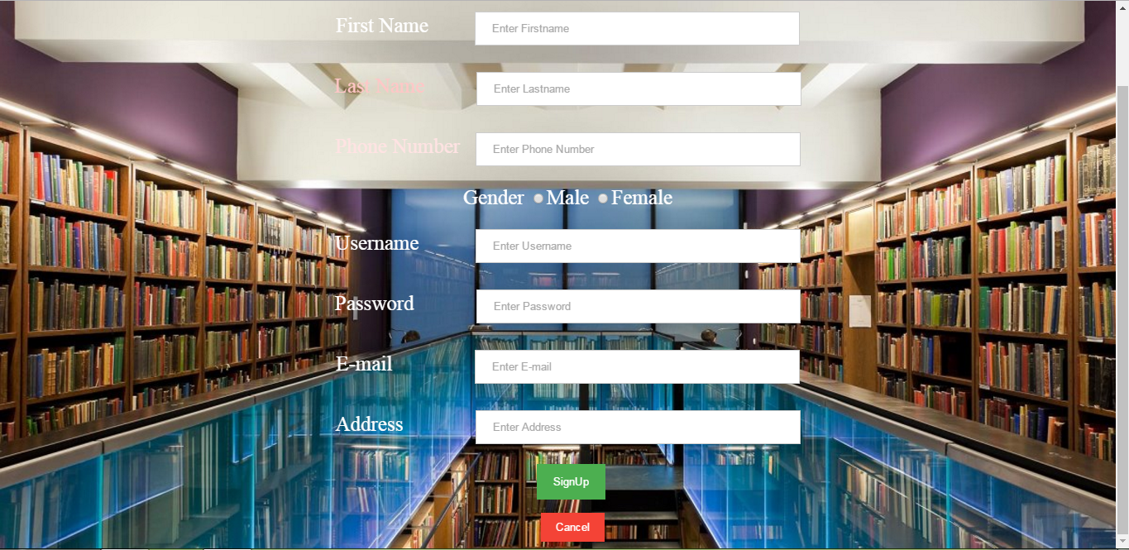

Fig.2 Sign up

The above prototype describes the sign up page for the website. It contains the details about the user that he needs to register if the user wants to reserve any book then he needs to register to this website. After filling the details in the form then he needs to click on the signup button. Then all the details given by the user is stored in the database. After that the user navigates to the home page.

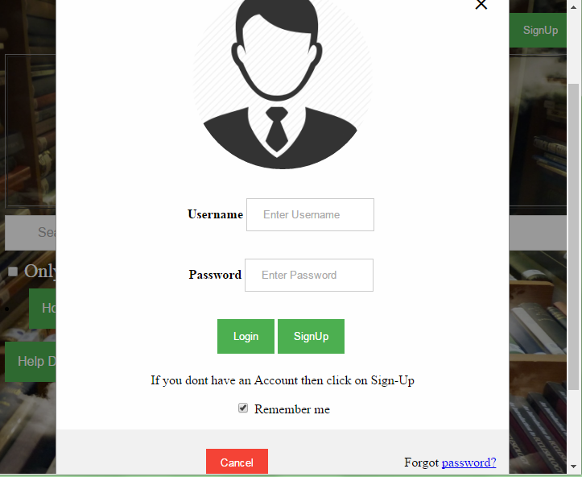

Fig.3 login page

The above prototype describes the user login details who are already registered to this website. It consists username and password if the user is new to use it we have specified the signup button to register with new account. After entering the username and password user has to click on the login button and it navigates to the home page if the details are correct. If the user entered the invalid username or password then user cannot login to the website.



Fig.4 Home Page

The above prototype describes the home page. On this website when user wants to register to this website then he clicks on signup button. By clicking on sign up button he gets form to get registered. By clicking on login button he gets login form. If he wants to search any book then he has to enter the book name or author name in search box. This webpage contains menus like home, genre, book cart, feedback, helpdesk. By clicking on the menu he can select what he need.

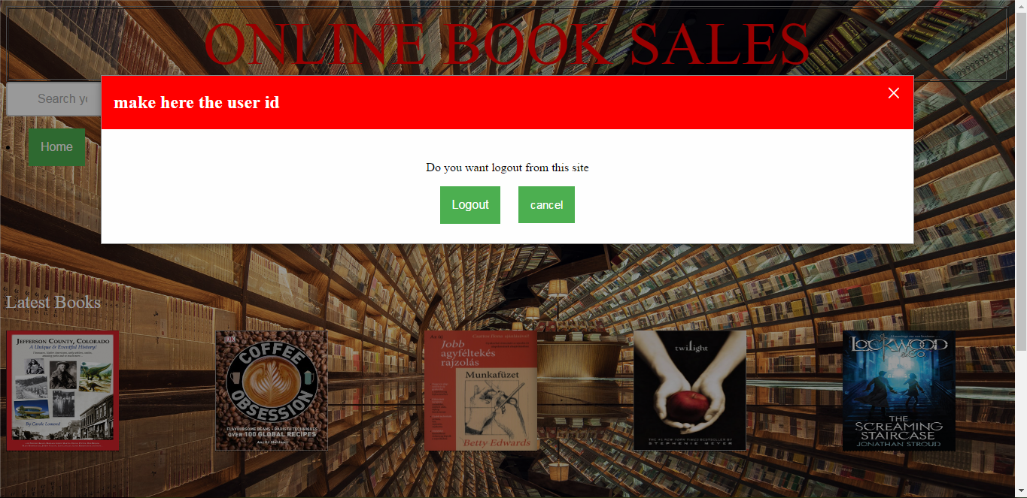

Fig. 5 Logout page

The above prototype describes about the user after completion of his work. If user needs to logout from his account then user needs to click on logout button. After clicking on logout button whatever changes that user mode will be updated in the database. If user wants to continue then user click on the cancel button.

**3.2 Performance Requirement**

* Any interface between user and OBSM should have a maximum response time of 5 seconds.
* The response should be fast enough to avoid users response collisions.
* The OBSM should be available 24*7.
* The OBSM should support 500 patterns and 1000 requests per minute simultaneously.
  1. **Design Constraints**

The system shall be built using a standard web page development tool that conforms to either IBM’s CUA standards or Microsoft’s GUI standards.

* 1. **Security Requirements**
* The account management system shall only used by users with defined privileges.
* The book purchase report shall only be generated by managers/users.
* The database update data committed only after the managers have approved.
  1. **Maintainability Requirements**
* Changes must be verified at least once per day.
* The system should provide notifications automatically about reservation results, availability of reserved items through mobile SMS.
  1. **Reliability Requirements**
* System shall be recovered within 10 minutes if it is down.
* System shall be recovered without intervention at user terminal if it is down.
* System shall have 99% reliability all the time.
  1. **Availability Requirements**
* System must be extend to store and deliver new content media types.
* System must be able to extend the support for data sharing between records.
  1. **Database Requirements**

A database that stores all the tables required for the system and also stores all the books information, transactions, account details and also the updated information about the system is necessary. The database should be highly secured and the information regarding the system should be stored.

* 1. **Documentation Requirements**
* All the information that is necessary to show the details about the books should be displayed.
* Whenever there is a registration for a book the SMS should be sent as soon as possible.
  1. **Safety Requirements**
* The account details of one person should not be visible to another.
* The password and the list of books reserved should be secured.
* Data should be updated as soon as possible in the system.
* Displaying of false statements should be taken care of.
  1. **Operational Requirements**
* Whenever a book is reserved by the user SMS will be generated to his mobile.
* When the new books are arrived according to the interesting domain he is interested in it should be notified to him through mobile SMS.

**STRUCTURED ORIENTED ANALYSIS:**

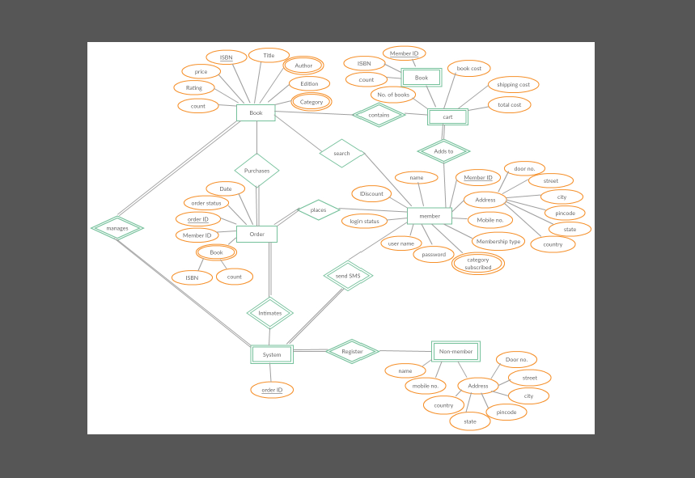

**OBJECT ORIENTED ANALYSIS:**

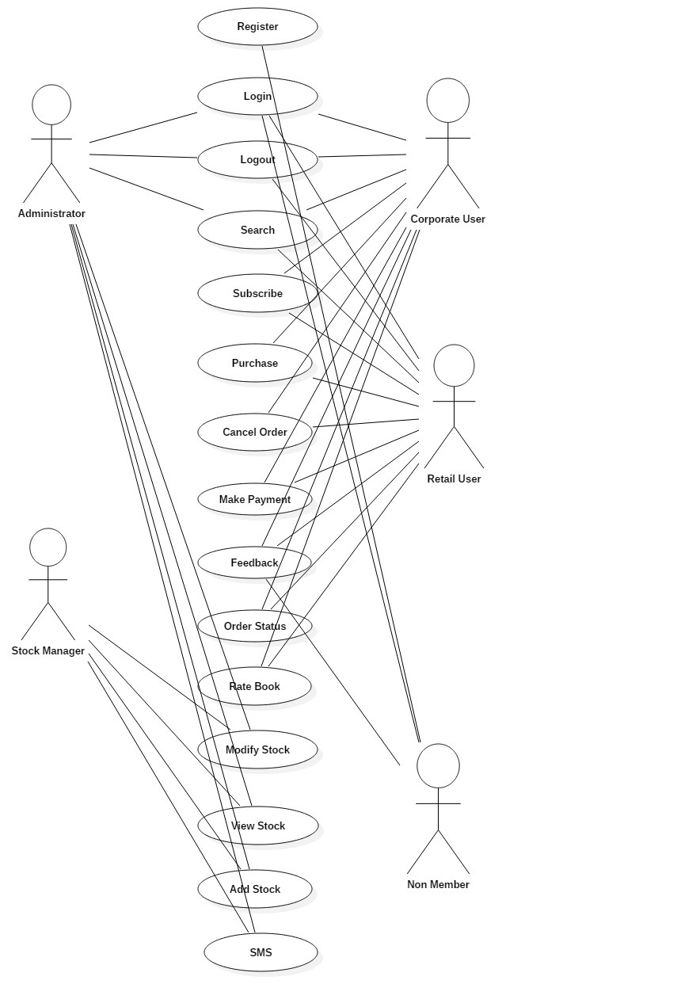

**TEST SCENARIO:**

